**R Code for Examples in the book**

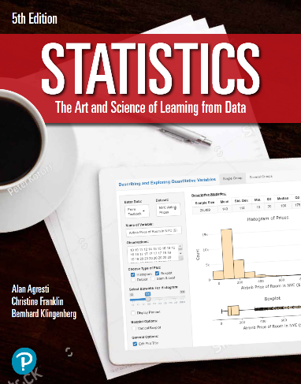

***“Statistics: The Art and Science of Learning from Data”***

**by Agresti, Franklin and Klingenberg, 5th edition**

**Chapter 10**

**Example 4: Confidence Interval for the Difference of Two Sample Proportions**

## Reading in data for the first proportion

x1 <- 347  
n1 <- 11535  
phat1 <- x1 / n1

## Reading in data for the second proportion

x2 <- 327  
n2 <- 14035  
phat2 <- x2 / n2

## To compute the mean of the difference

mean <- phat1 - phat2

## To compute the standard error of the difference

se <- sqrt((phat1 * (1 - phat1) / n1) + (phat2 * (1 - phat2) / n2))

## To find the zscore for a 95% confidence interval

zscore <- qnorm(0.975)

## To compute a 95% confidence interval for the difference of two proportions

round(mean + c(-1, 1) * zscore * se, 3)

## [1] 0.003 0.011

## 

## Alternatively, you can also use the prop.test() function

prop.test(c(347, 327), c(11535, 14035), correct = FALSE)

##   
## 2-sample test for equality of proportions without continuity  
## correction  
##   
## data: c(347, 327) out of c(11535, 14035)  
## X-squared = 11.352, df = 1, p-value = 0.0007536  
## alternative hypothesis: two.sided  
## 95 percent confidence interval:  
## 0.002790305 0.010776620  
## sample estimates:  
## prop 1 prop 2   
## 0.03008236 0.02329890